Stanwix Community Pre-School
Telephone: 01228 512630 January 2020
+
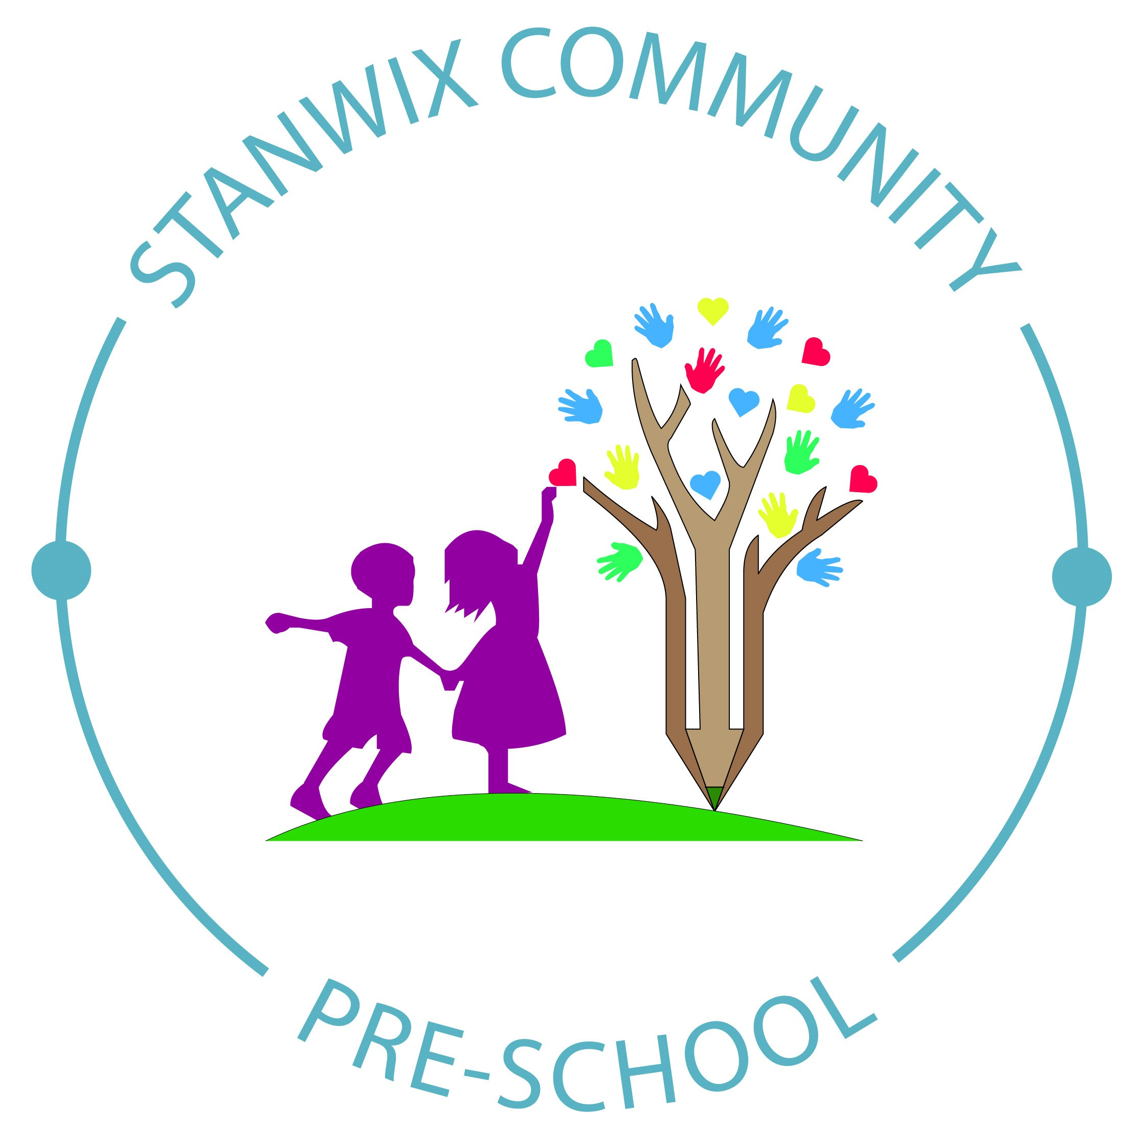
Planning
Planning W/C 6th & 13th Jan
People Who Help Us
- Talk about the different roles and occupations people have and how they help us and others.
- Arrange visits from the Fire Service, Police, Nurse, Opticians
- Dentist – Importance of cleaning and looking after our teeth, including a visit from a Dentist as part of a Dental Oral Survey we are taking part in.
- Provide dressing up outfits for the children to take on a role.
- Police Finger prints on the craft table
If there are any parents whose occupation is based around our ‘People who help us’ theme and are willing to come in and give a talk and/or a demonstration of their role, it would be greatly appreciated.
Please do not be put off by giving a talk, the staff will be there to help. It doesn’t have to be long and if you can bring some of your equipment (that you don’t mind them touching!), the children really enjoy exploring new and different things.

Nursery Rhymes
Why are Nursery Rhymes so Important?

Research has found that when a child knows eight or more nursery rhymes by heart, at the age of 4, they are usually one of the best at reading and spelling in their class by the age of 8!
Please see the next page for more details.

Becky, Rhona, Megan, Helen, Stacey & Angela
Dates for your diary
Next Committee Meeting
Thursday 16th January @ 7.30pm
Half Term
17th – 21st February 2020
School Application Closing Date
Wednesday 15th January 2020

For th
.
Thank You
Welcome back to Pre-School after the Christmas Break. We hope you all had a fantastic Christmas and New Year.
Thank you for all of our lovely cards and gifts we received.

School Applications

Please do not forget to apply for your child’s school place by Wednesday 15th January 2020. You can apply online at:
www.cumbria.gov.uk/schooladmissions

Shared Snack Time

We operate a ‘rolling snack’ system with all the fruit donations we receive. This is placed in a large bowl and shared out between everyone. Therefore, it makes it more difficult if children bring in individual items for snack time as children can become upset if someone wants to share their snack. This can also happen if they bring in a piece of fruit but may not eat it during the session, some children will ask for it back and unfortunately it has usually been eaten! We would be grateful if you could please explain and support your child with our snack time routine. Thank you

Spare Clothing

Our emergency supplies are running low. It would be greatly appreciated, if you have any of our spare clothing to return it, as soon as possible.

Many Thanks
Becky, Rhona, Megan, Helen, Angela & Stacey

What do children learn from Nursery Rhymes?
- Nursery rhymes are easy to repeat so become part of your child’s first sentences.
When we sing or say nursery rhymes, we tend to speak more slowly and clearly so children learn how the words are formed. This is great, because it makes it easier for little ones to join in.

- Nursery rhymes help children practice pitch, volume and the rhythm of language.
Music and rhymes help children learn a steady beat, which helps with language and reading development. Joining in with clapping and actions, like baby signing, can help this development.

- Nursery rhymes are a great way to develop early phonic skills.
Through hearing and repeating nursery rhymes, children have the opportunity to hear, identify an manipulate letter sounds.

- Nursery rhymes expand children’s imagination.
Nursery rhymes often tell a story and create imagery. Children can imagine a world where vinegar and brown paper are a remedy for a head injury!

- Nursery Rhymes follow a clear sequence of events.
They often tell a story and contain a beginning, middle and end.

- Nursery rhymes teach early maths skills.
Many contain numbers, counting, colours and other maths vocabulary such as weight and size.

- Nursery Rhymes improve vocabulary.
Children hear and use new words that they wouldn’t come across in everyday language. For example, in Jack and Jill they ‘fetch’ a ‘pail’ of water.

- Nursery rhymes provide examples of literacy devices.
They use alliteration (the occurrence of the same letter or sound at the beginning of adjacent or closely connected words) such as ‘Goosey, Goosey, Gander’ onomatopoeia (formation of a sound associated with what is named) in ‘Baa Baa Black Sheep’ and rhyme.

- Nursery Rhymes teach emotions.
The characters in the rhymes experience a range of emotions, which can help children to understand and identify their own emotions and those of others.

- Nursery Rhymes are fun and transportable!
Nursery rhymes are a great way to spend time with your child and they don’t require any equipment.
Children love the sound of your voice over any other. They are not bothered if you are not a great singer!!
Often nursery rhymes are funny – some make little sense; others have unexpected endings. If you forget the words or are feeling creative, you can make up some of your own versions!

